SMART SORTING PROJECT REPORT

1. INTRODUCTION
1.1 Project Overview
Smart Sorting: Transfer Learning for Identifying Rotten Fruits and Vegetables is an intelligent image-based classification system designed to automatically detect and classify fruits and vegetables as fresh or rotten. The project uses deep learning and transfer learning techniques to improve accuracy and efficiency in food quality inspection.
In many food processing units, supermarkets, and households, manual inspection of fruits and vegetables is time-consuming, labor-intensive, and prone to human error. The Smart Sorting system provides an automated solution that analyzes images captured through cameras or uploaded by users and classifies the produce based on visual characteristics such as color, texture, and surface defects.
The system helps reduce food waste, improve quality control, and support smart agricultural and food management practices by providing fast and reliable classification results.

1.2 Purpose
The purpose of this project is to develop an intelligent, accurate, and user-friendly system that automatically identifies fresh and rotten fruits and vegetables using transfer learning and deep learning techniques. The system aims to improve food quality inspection and reduce manual effort.
The project ensures:
• Automated detection of rotten fruits and vegetables
• Faster and more reliable classification results
• Reduced food wastage through early detection
• Improved efficiency in food processing and retail environments
• Support for smart and scalable quality control systems

2. IDEATION PHASE

2.1 Problem Statement
In the agricultural and food supply chain, identifying rotten fruits and vegetables is often done manually, which is inefficient, time-consuming, and subject to human error. Poor lighting conditions, large volumes of produce, and lack of automated systems make accurate inspection difficult. As a result, spoiled produce may reach consumers or lead to increased food waste.
There is a need for an automated, intelligent system that can accurately detect and classify fresh and rotten fruits and vegetables using image processing and deep learning techniques. Such a system can improve quality control, reduce wastage, and enhance operational efficiency in food processing units, supermarkets, and smart homes.
How Might We:
How might we enable citizens to report issues and track resolutions in a transparent, efficient, and accountable manner—without needing to visit government offices physically?

2.2 Empathy Map Canvas
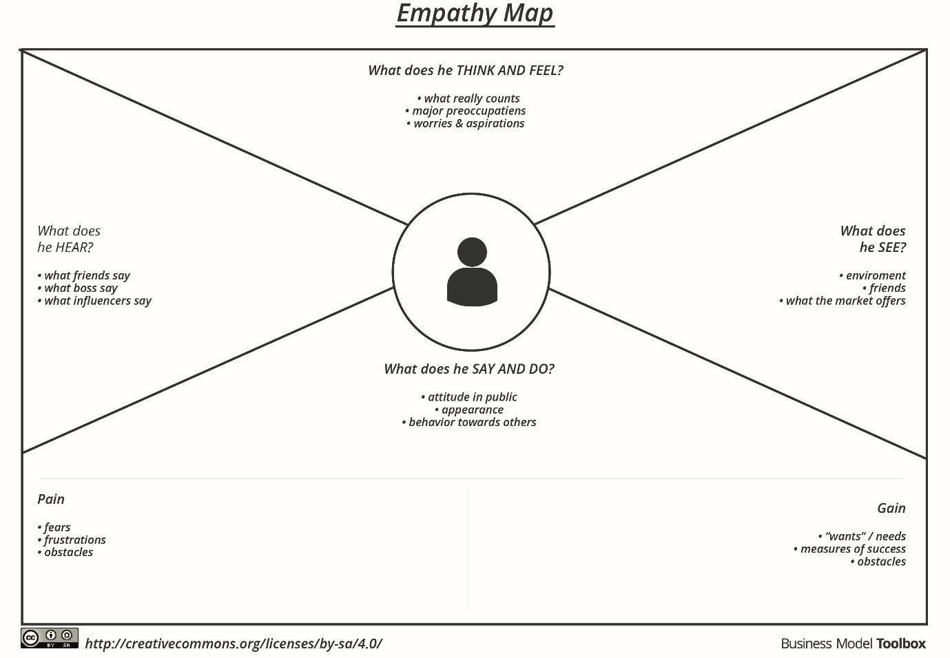
Says:
“I need a faster way to identify rotten fruits and vegetables.”
“Manual checking takes too much time and effort.”
Thinks:
“Is there a reliable system that can accurately detect spoiled produce?”
“How can I reduce food waste and avoid sending rotten items to customers?”
Feels:
Concerned about food quality and safety
Frustrated with manual sorting errors
Worried about customer dissatisfaction and losses
Does:
Manually inspects fruits and vegetables one by one
Separates produce based on visual judgment
Discards items after late detection of spoilage
Looks for automated or smart solutions to improve efficiency

2.3 Brainstorming
During the brainstorming session, the team explored various ideas to improve the detection and classification of fresh and rotten fruits and vegetables using intelligent systems. The goal was to design an efficient, accurate, and scalable solution that reduces manual effort and food waste. Some of the key ideas discussed are listed below:
• Automated image-based detection of fresh and rotten fruits and vegetables
• Use of transfer learning with pre-trained deep learning models to improve accuracy
• Real-time image capture using cameras for continuous inspection
• Image preprocessing techniques to enhance feature extraction
• Support for multiple types of fruits and vegetables
• User-friendly web interface for easy image upload and result visualization
• Integration with automated sorting systems in food processing units
• Analytics and performance monitoring to evaluate model accuracy and efficiency

3. REQUIREMENT ANALYSIS

3.1 User Journey Map
The user journey for the Smart Sorting: Transfer Learning for Identifying Rotten Fruits and Vegetables system includes the following key stages:
• Awareness:
The user becomes aware of the Smart Sorting system through industrial adoption, academic use, food quality initiatives, or technology demonstrations.
• Registration/Login:
New users (operators or administrators) register using basic credentials, while existing users log in securely to access the system.
• Image Upload or Capture:
The user uploads images of fruits and vegetables or enables a camera feed for real-time image capture in the inspection environment.
• Image Processing and Classification:
The system preprocesses the images and uses a transfer learning–based deep learning model to classify the produce as fresh or rotten.
• Result Visualization:
The classification results are displayed clearly on the dashboard, indicating whether the fruit or vegetable is fresh or rotten.
• Decision and Action:
Based on the results, the user takes appropriate action such as separating or discarding rotten produce to maintain quality standards.

3.2 Solution Requirement

Functional Requirements:
• User registration and secure login for operators and administrators
• Upload images or capture real-time images using a camera
• Automatic image preprocessing for feature extraction
• Classification of fruits and vegetables as fresh or rotten using transfer learning
• Display of prediction results on a user-friendly dashboard
• Admin access to manage users, datasets, and system settings
• Storage of prediction results for monitoring and analysis
• Support for multiple fruit and vegetable categories

Non-Functional Requirements:
• Fast prediction response time for image classification
• Secure data handling and role-based access control
• User-friendly and responsive interface across different devices
• High system reliability and availability
• Scalable architecture to support additional data and users
• Maintainability and flexibility for future model updates

3.3 Data Flow Diagram
Level 0 DFD:
External Entities:
• User / Operator
• Admin
Processes:
User Registration and Login
• Image Upload or Image Capture
• Image Preprocessing
• Fresh/Rotten Classification
• Result Display and Monitoring
Data Stores:
• Users Database – stores registered user and admin details
• Image Dataset – stores uploaded images and training data
• Prediction Results Database – stores classification results and timestamps
• Model Storage – stores trained deep learning models
Data Flow Description:
The user logs into the system and uploads or captures images of fruits and vegetables. The images are preprocessed and passed to the trained transfer learning model. The system classifies the produce as fresh or rotten and stores the prediction results. The results are displayed to the user, while the admin monitors system performance and manages datasets and models.
3.4 Technology Stack
• Frontend:
HTML, CSS, JavaScript (for web interface)
• Backend:
Python with Flask framework (to handle server-side logic and model integration)
• Deep Learning Framework:
TensorFlow and Keras (for building and training transfer learning models)
• Model Architecture:
Pre-trained Convolutional Neural Network models (e.g., MobileNetV2)
• Database:
SQLite or MySQL (to store user details and prediction results)
• Authentication:
Email and password–based authentication
• Development Environment:
Anaconda Navigator, Jupyter Notebook
• Hosting / Deployment:
Local server or cloud platform (AWS / Heroku / Render)

4. PROJECT DESIGN

4.1 Problem-Solution Fit
The proposed Smart Sorting system addresses the problem of inefficient and error-prone manual inspection of fruits and vegetables by providing an automated, intelligent solution. Traditional quality inspection methods are time-consuming, labor-intensive, and often inaccurate due to human limitations.
The Smart Sorting solution uses image processing and transfer learning techniques to automatically identify fresh and rotten fruits and vegetables. This approach improves accuracy, reduces inspection time, minimizes food wastage, and enhances overall efficiency in food processing units, supermarkets, and smart home environments.

4.2 Proposed Solution
The proposed solution is a web-based intelligent system where:
• Users or operators can upload images or capture real-time images of fruits and vegetables
• The system preprocesses images and applies a transfer learning–based deep learning model
• Fruits and vegetables are automatically classified as fresh or rotten
• Results are displayed instantly on a user-friendly interface
• Admins can manage users, datasets, and monitor system performance
This solution enables fast, reliable, and scalable quality inspection without manual intervention.
4.3 Solution Architecture
Architecture Type: Client–Server Model
Layers:
• UI Layer:
Web-based interface used by operators and administrators to upload images and view classification results
• Application Layer:
Backend server that handles image preprocessing, model inference, and business logic
• Model Layer:
Transfer learning–based deep learning model responsible for feature extraction and classification
• Data Layer:
Database and storage used to maintain user details, uploaded images, prediction results, and trained models

5. PROJECT PLANNING & SCHEDULING
5.1 Project Planning
We followed the Agile Methodology with 6-day sprints to develop the project in phases:
Sprint | Total Story Points | Duration | Sprint Start Date | Sprint End Date (Planned) | Story Points Completed (as on Planned End Date) | Sprint Release Date (Actual)
Sprint-1 | 20 | 6 Days | 14 Feb 2026 | 20 Feb 2026 | 20 | 20 Feb 2026
Sprint-2 | 20 | 6 Days | 14 Feb 2026 | 20 Feb 2026 | 20 | 20 Feb 2026
Sprint-3 | 20 | 6 Days | 14 Feb 2026 | 20 Feb 2026 | 20 | 20 Feb 2026
Sprint-4 | 20 | 6 Days | 16 Feb 2026 | 20 Feb 2026 | 20 | 20 Feb 2026

6. FUNCTIONAL AND PERFORMANCE TESTING

6.1 Performance Testing
Performance testing was conducted to evaluate the efficiency, responsiveness, and stability of the Smart Sorting system under different conditions. The goal was to ensure that the system performs reliably while processing image inputs and generating classification results.
Tools Used:
• Postman for testing backend API responses
• Python-based testing for measuring model prediction time

Test Scenarios:
• Simulated multiple image upload requests
• Measured image processing and prediction response time
• Evaluated system performance during continuous image classification
• Checked backend stability during repeated predictions
Results:
• The system handled multiple image inputs without failure
• Average prediction response time was less than 2 seconds per image
• Image preprocessing and classification were performed efficiently
• No system crashes or prediction errors were observed during testing

7. RESULTS

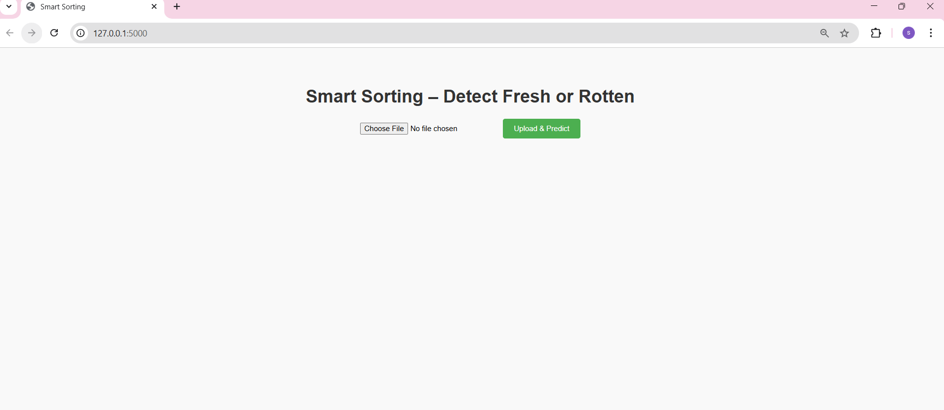
Fig: Interface

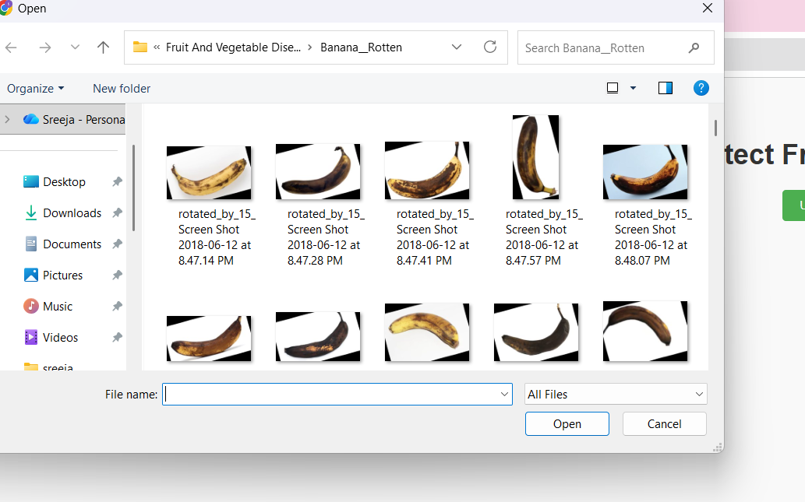
Fig: File Upload
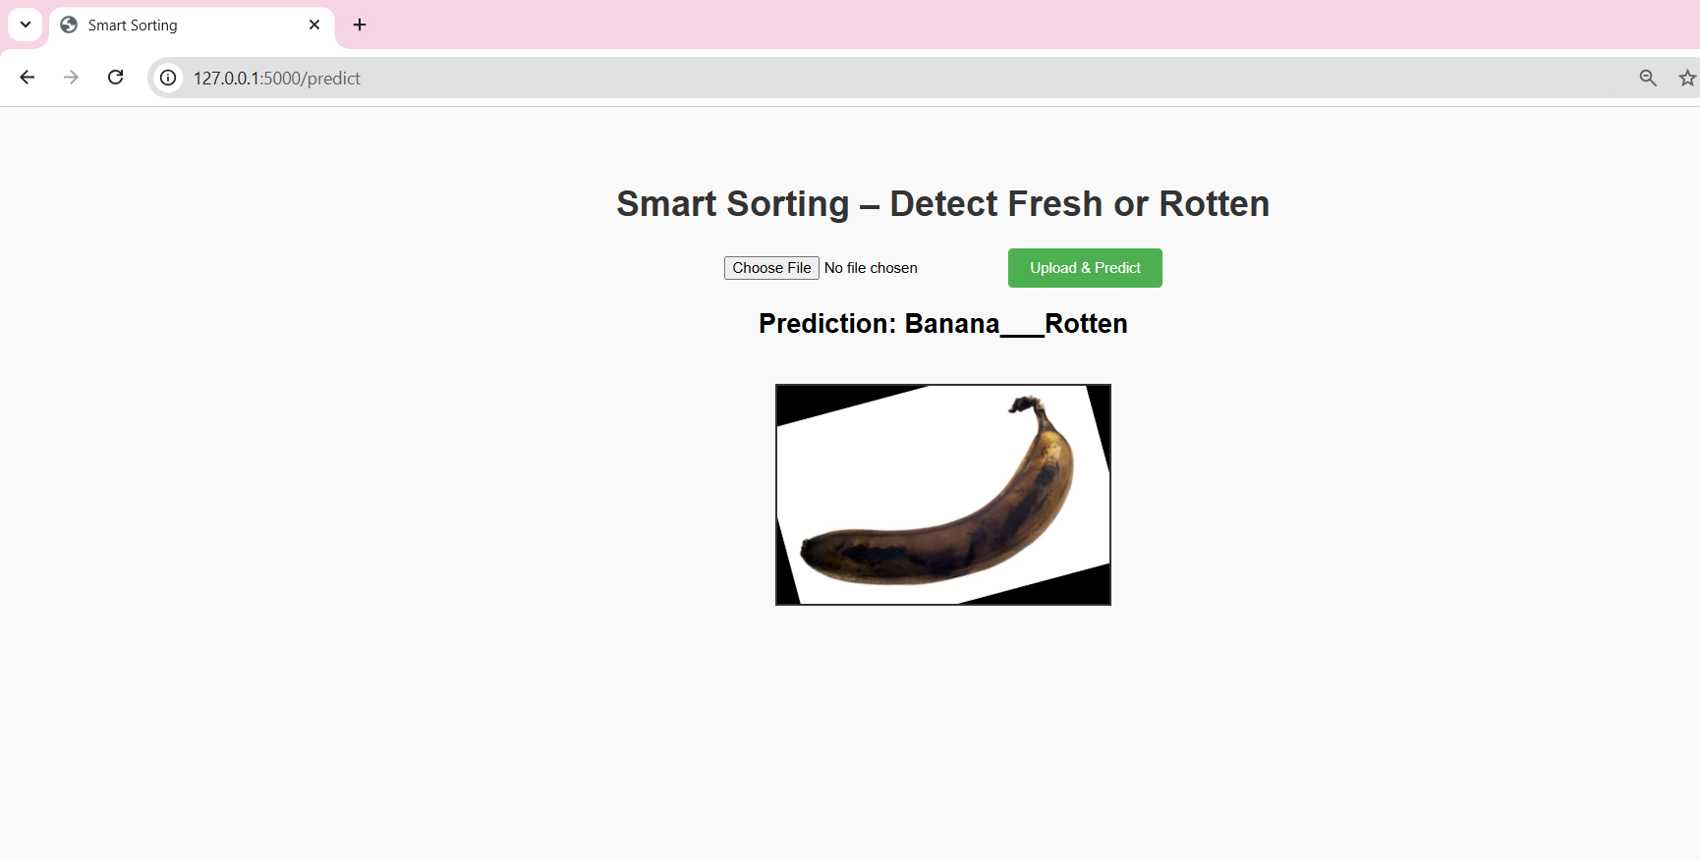
Fig: Banana Detection

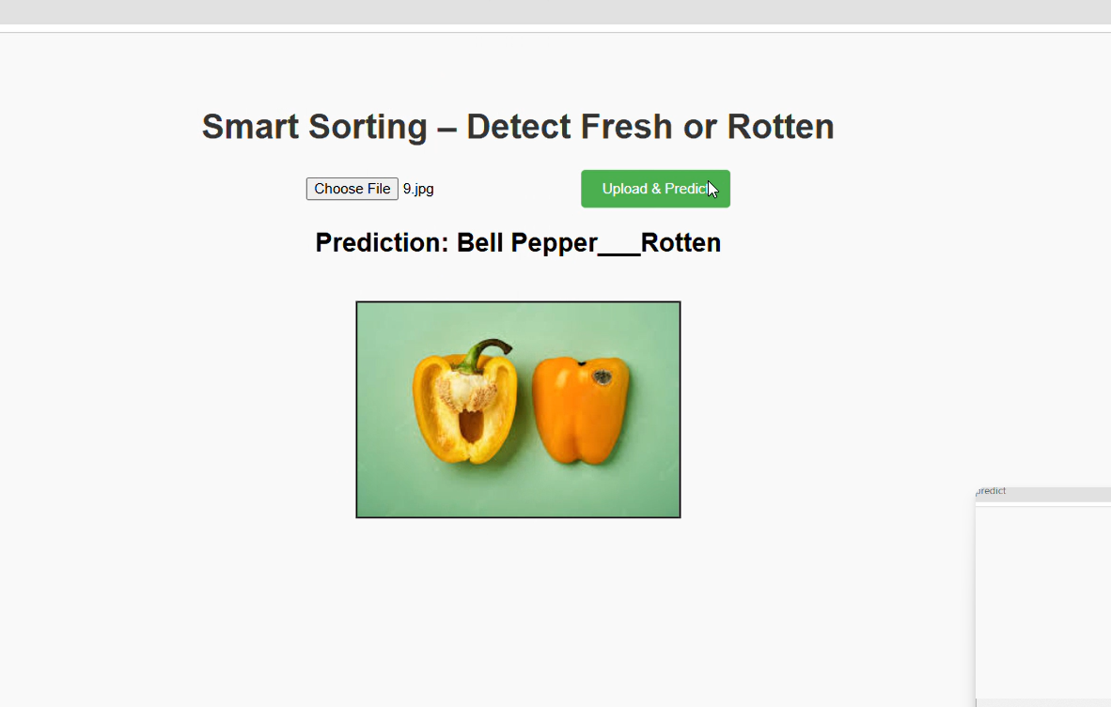
Fig: Rotten Bell Pepper Detection

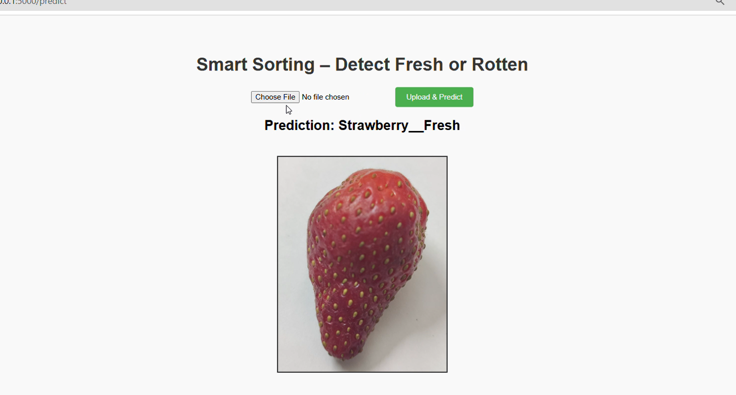
Fig: Fresh Strawberry Detection
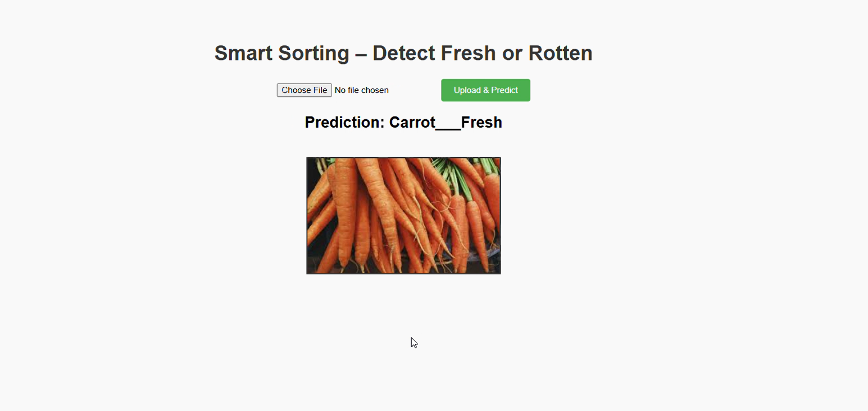
Fig: Fresh carrot Detection

8. ADVANTAGES & DISADVANTAGES

Advantages:
• Saves time by automating the detection of rotten fruits and vegetables
• Reduces manual effort and human error in quality inspection
• Provides fast and accurate classification results
• Easy to use with a simple and user-friendly interface
• Helps reduce food waste and improves quality control
• Can be used in food processing units, supermarkets, and smart homes

Disadvantages:
• Requires a stable internet connection for web-based access
• Initial model training and setup may require computational resources
• Accuracy depends on image quality and lighting conditions

9. CONCLUSION
The Smart Sorting: Transfer Learning for Identifying Rotten Fruits and Vegetables project successfully demonstrates an intelligent and automated approach to food quality inspection. By leveraging deep learning and transfer learning techniques, the system efficiently classifies fruits and vegetables as fresh or rotten.
The proposed system reduces manual inspection efforts, minimizes food waste, and improves operational efficiency. The user-friendly interface and scalable design make the solution suitable for real-world applications in food processing industries, retail environments, and smart homes.

10. FUTURE SCOPE
• Integration with real-time camera systems for conveyor belt automation
• Expansion of the dataset to include more fruit and vegetable categories
• Deployment of mobile applications for on-the-go image capture and monitoring
• Use of advanced deep learning models to further improve accuracy
• Integration with automated sorting machines for physical separation of produce
• Implementation of analytics dashboards for performance and quality monitoring

11. APPENDIX

Source Code :
https://github.com/sreejaalle/Smart_Sorting

